Prosit 2 – Workshop

**QUESTIONS**

1. Define a DBMS
2. Describe the roles of DBMS in data management
3. Describe the different types of DBMS
4. Explain the advantages of using DBMS
5. Explain the difference between a file system and a DBMS

**ANSWERS**

1. A Database Management System (DBMS) is a software system that is designed to manage and organize data in a structured manner. It allows users to create, modify, and query a database, as well as manage the security and access controls for that database. DBMS provides an environment to store and retrieve data in convenient and efficient manner.
2. Roles of DBMS in data management include:
   * Backup and recovery
     + If the system fails due to some reason, then it recovers the data and keeps the data safe.
   * Data sharing and data integrity
     + Multi user access control makes sure the integrity of the data present in the database. It also follows the ACID property, so the database will be consistent while multiple users are accessing it concurrently.

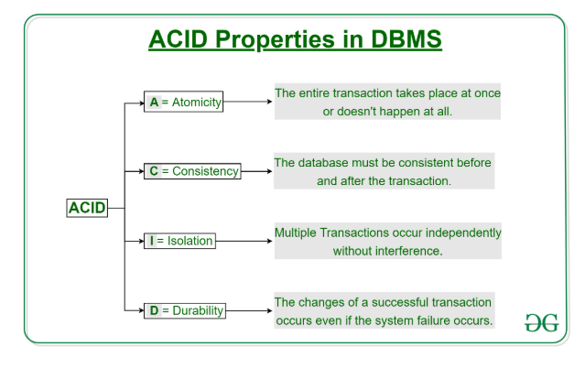

* + Data independence
    - DBMS provides the data abstraction and removes the dependency of the data from the system.
  + Security
    - There are certain security rules that ensure what data can be accessed from the database and which user can access it. It also makes sure what operations (read, write, delete) can be performed on the specific data. It is very important for the organizations where multi-user databases are required.
  + Storage
    - Modern database systems not only provide storage for the data but they store and manage the metadata (data of data) like data procedural rules, validation rules etc. DBMS also provides performance tuning, which makes accessing data faster and easier.
  + Improved data accessibility
    - DBMS provides the functionality of data transformation, which means programmers need not worry about the logical and physical representation of the data. DBMS stores the data in the determined data structure.
  + Data manipulation

1. Types of DBMS are as follows:
   * Relational Database Management System (RDBMS): Data is organized into tables (relations) with rows and columns, and the relationships between the data are managed through primary and foreign keys. SQL (Structured Query Language) is used to query and manipulate the data.
   * NoSQL DBMS: Designed for high-performance scenarios and large-scale data, NoSQL databases store data in various non-relational formats such as key-value pairs, documents, graphs, or columns.
   * Object-Oriented DBMS (OODBMS): Stores data as objects, similar to those used in object-oriented programming, allowing for complex data representations and relationships
   * Hierarchical DBMS: Data is stored in a tree-like structure with parent-child relationships. Example: IBM Information Management System (IMS).
   * Network DBMS: Data is organized in a graph structure allowing many-to-many relationships. Example: Integrated Data Store (IDS).
2. Advantages of data:
   * Data organization: A DBMS allows for the organization and storage of data in a structured manner, making it easy to retrieve and query the data as needed.
   * Data integrity: A DBMS provides mechanisms for enforcing data integrity constraints, such as constraints on the values of data and access controls that restrict who can access the data.
   * Concurrent access: A DBMS provides mechanisms for controlling concurrent access to the database, to ensure that multiple users can access the data without conflicting with each other.
   * Data security: A DBMS provides tools for managing the security of the data, such as controlling access to the data and encrypting sensitive data.
   * Backup and recovery: A DBMS provides mechanisms for backing up and recovering the data in the event of a system failure.
   * Data sharing: A DBMS allows multiple users to access and share the same data, which can be useful in a collaborative work environment.
3. Difference between file system and DBMS:

|  |  |
| --- | --- |
| **File System** | **DBMS** |
| The file system is a way of arranging the files in a storage medium within a computer. | DBMS is software for managing the database. |
| Redundant data can be present in a file system. | In DBMS there is no redundant data. |
| It doesn’t provide Inbuilt mechanism for backup and recovery of data if it is lost. | It provides in house tools for backup and recovery of data even if it is lost. |
| There is no efficient query processing in the file system. | Efficient query processing is there in DBMS. |
| There is less data consistency in the file system. | There is more data consistency because of the process of normalization. |
| Less complex | More complex |
| Less security | More security mechanisms |
| Less expensive | Comparatively higher cost |
| No data independence | In DBMS data independence exists, mainly of two types:   * Logical Data Independence * Physical Data Independence |
| Only one user can access data at a time. | Multiple users can access data at a time. |
| The users are not required to write procedures. | The user must write procedures for managing databases |
| Data is distributed in many files. So, it is not easy to share data. | Due to centralized nature data sharing is easy |
| It gives details of storage and representation of data | It hides the internal details of Database |
| Integrity Constraints are difficult to implement | Integrity constraints are easy to implement |
| To access data in a file, user requires attributes such as file name, file location. | No such attributes are required. |
| Examples – Cobol, C++ | Examples – Oracle, SQL Server |